Project Design Phase-II
Technology Stack (Architecture & Stack)

Date | JUNE 2026
Team ID
Project Name | INDIAN AGRICULTURE CROP PRODUCTION ANALYSIS
Maximum Marks | 4 Marks
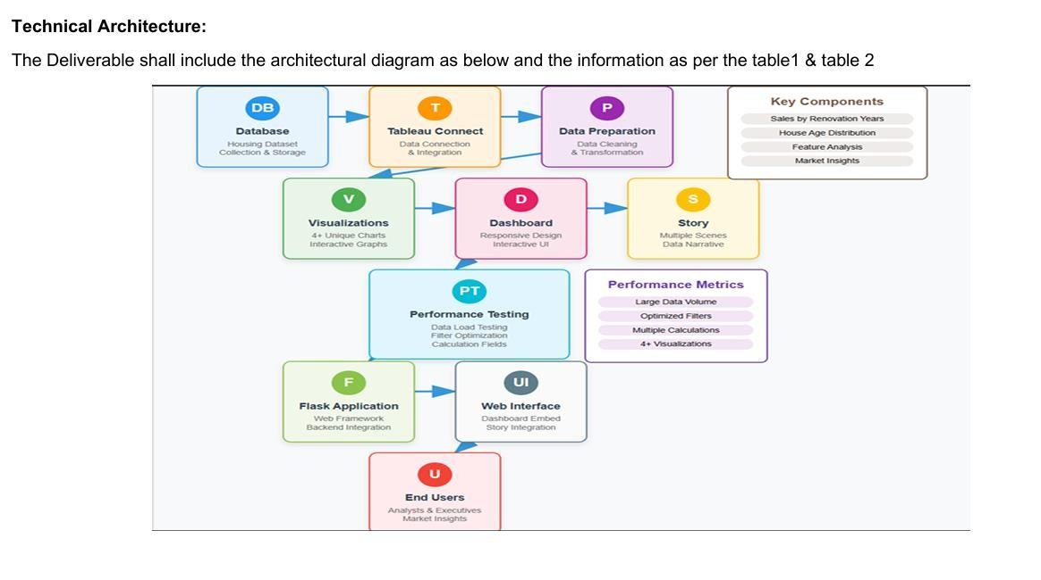

Table-1 : Components & Technologies:

S.No | Component | Description | Technology
1. | User Interface | Web-based dashboards for viewing and interaction | HTML, CSS, JavaScript / Tableau Public
2. | Application Logic-1 | Data preprocessing and transformation workflows | Tableau Prep Builder
3. | Application Logic-2 | Interactivity using filters, parameters, and actions | Tableau Filters, Parameters, Actions
4. | Dashboard/Story Logic | Logical flow of insights using story features | Tableau Story Feature
5. | Data Source | Flat files used as World Heritage datasets | CSV
6. | File Storage | Heritage datasets stored and accessed locally or from cloud storage | Local File System / Google Drive

Table-2: Application Characteristics:
S.No | Characteristics | Description | Technology
1. | Open-Source Frameworks | Uses open-source data (UNESCO dataset), hosted on Tableau Public | Dataset – CROP PRODUCTION (CSV)
2. | Security Implementations | Basic security (view-only links, no edit access on public dashboard) | Tableau Public (limited)
3. | Scalable Architecture | Can scale by publishing to Tableau Cloud or embedding in websites | Tableau Cloud / Web Embed
4. | Availability | Dashboards accessible 24/7 via Tableau Public | Tableau Public
5. | Performance | Performs well with moderate data size; quick filter responsiveness | Tableau Public

References:
https://c4model.com/ https://developer.ibm.com/patterns/online-order-processing-system-during-pandemic/ https://www.ibm.com/cloud/architecture https://aws.amazon.com/architecture https://medium.com/the-internal-startup/how-to-draw-useful-technical-architecture-diagrams-2d20c9fda90d

